Course Work Cover Sheet - The School of Computing

Author’s Name: Kyle Harrison; Richard Dowdalls; Toby Philp; Daniel Joyce

Matriculation
Numbers: 110009870; 090004575; 050005919; 100016064

Module Code: AC21003

Assignment Title: Project Management - 1A

Date Submitted: 13/02/12

Date Due to be
Submitted:

Word Count

Your course work may be used by The School of Computing for demonstration purposes with other classes and/or members of the public, unless you indicate otherwise. Tick the box at the right if you do not wish your work to be used in this way. | ❒

I certify that this assignment represents all my own work and that no parts of it have been copied and that no collusion has taken place with any other person. I have also read and understood The School of Computing’s regulations as regards course work and I certify that this course work was performed according to those regulations.

I certify that any disks submitted with this assignment have been virus checked and have no viruses on them.

Signed: ………….…..<Name>

Database – Assignment 3

Summary of Customer actions

The following is a summary of the set of actions that the customer will want to do with the database. In this section we assume that the customers of the database will be both the customers and the staff of MVVT as these will be the customer’s actions we will need to identify and address when using the database.

Data availability and accessibility
MMVT will store information regarding customers such as personal information, vehicle information, information detailing work carried out on the customer vehicle and will only use it for the specific purposes it was collected which is maintain records on customers and jobs completed. This information is recorded and stored in an online database that shall be accessible by using a computer, phone, or other hand-held device with an internet connection to both staff and customers ( with customers only being granted access to their own personal information).

Customers have the right to access their own personal information and any other information regarding them as stated in the Data Protection Act (1998) and this is an action they may want to do with the database. A customer may want to remove information no longer necessary such as their personal details after a job is complete if they no longer wish to use the services available at MMVT. Alternatively customers may decide to change information regarding them to keep it up to date such as a change in contact details to ensure they are contacted appropriately when a job is complete. These actions may also have to be performed by MMVT staff for their own personal information and on behalf of customers if they choose to request services from MMVT thought any form of contact that is not the website. Some of the actions a customer may carry out in the database regarding information access and availability are the following:

Customer and MMVT Staff
- Access to personal information to view it, make changes and delete it if needed.
- Access to vehicle information to view, change or delete if necessary.
- Access information regarding jobs to view the progress of work carried out. E.g. if the job is complete and the vehicle is ready for collection.
- Access all previous jobs carried out on a vehicle such as a vehicle history.
- Change the password associated with an account to ensure secure accessibility

Services offered thought the database
Customers to MMVT will want to make use of the information stored within the database as without it being beneficial to them there is little incentive to use the web service and supply the information needed to the database. By offering services thought the website for the database it causes customers to engage and supply the information needed to maintain and fill the database allowing the services to be rendered. Information held on customers and their vehicles is updated throughout the process of first interaction with the MMVT when an account is created and customer information is stored until a job has been completed. Some of the actions customers may carry out with the database regarding services available thought the database is the following:

- Query the database to view changes to the status of jobs.
- Submit an enquiry requesting a quote regarding a specific problem.
- View all available invoices for work carried out. E.g. Job history.
- View available bookings and request a booking slot on the system

Actions performed by MMVT Staff
In addition to everything a customer can do MMVT staff will also need to perform the following :

- Produce Invoice when a job has been completed
- Generate booking information and allocate resources when a customer submits a request
- Submit working hours of individual staff members to manage resources
- Access/ Update / remove parts to add to invoices to calculate prices
- Generate a quote based on an enquiry made
- Manage photographs of vehicles that customers submit and those taken during work.
- Update job details as a job progresses

Entities and Attributes

Based requirements gathering and analysis it has been identified that the system will be required to retain data that describes customer details, vehicle details, booking information and information about the work carried out.

After careful consideration of what exactly each of these general concepts require the following entities have been derived to form the basis of the database design:

Customer | Contains attributes that describe required customer information such as name and phone number.
Address | Contains a single address entry for each customer.
Account | Attributes specify login information used by bother customers and staff members.
Vehicle | Attributes describe a specific vehicle that has or will be worked on by the garage.
Staff | Defines a staff member at a basic level required for allocation purposes.
Booking | Defines a booking appointment for a job to be carried out on a vehicle as requested by a customer.
Job | Contains information that relates to a specific job being done on a vehicle.
Invoice | Contains invoice specific details such as the invoice data and the total cost.
Part | Models a single billable item that may be listed on an invoice for a job.
Photograph | A photograph and a time stamp that can be used to create a historical record related to a job.
Manufacturer | Contains a description which identifies a single manufacturer of vehicles (cars,bikes..)
Model | Contains a description which identifies a single vehicle model and the manufacturer who makes it.
BookingType | Defines a type of booking for example one where the vehicle is to be collected from the customers home or a roadside assistance.
StaffAllocation | Serves as a connection between a staff member and a specific job, each entry provides a job and a staff member.

Each of these proposed entities have been more tightly defined in terms of their attributes, data types, field sizes and other relevant notes using a data dictionary as the cleanest way to represent them.

Data Dictionary

The data dictionary contains all of the attributes of the entities within the database.

Customer
Field Name | Data type | Field size / format | Required | Indexed | Comments
id | INT | n/a | Yes | Yes | Primary Key
firstName | VARCHAR | 20 | Yes | No | Must be alphabetical
surname | VARCHAR | 30 | Yes | No | Must be alphabetical
homePhoneNumber | VARCHAR | 15 | No | No | Must be numeric
mobilePhoneNumber | VARCHAR | 15 | No | No | Must be numeric
emailAddress | VARCHAR | 45 | No | No | none
Account_username | VARCHAR | 45 | No | Yes | FK to account table

Address
Field Name | Data type | Field size / format | Required | Indexed | Comments
Customer_id | VARCHAR | 45 | Yes | Yes | FK to Customer table and PK in an identifying relationship.
addressLine1 | VARCHAR | 70 | No | No | none
addressLine2 | VARCHAR | 70 | No | No | none
town | VARCHAR | 45 | No | No | Can only contain letters
postcode | VARCHAR | 10 | No | No | Must not contain symbols

Account
Field Name | Data type | Field size / format | Required | Indexed | Comments
username | VARCHAR | 45 | Yes | Yes | Primary Key
password | VARCHAR | 32 | Yes | No | Stored as 32 bit hash
type | VARCHAR | 8 | Yes | No | Flag staff/customer

Model
Field Name | Data type | Field size / format | Required | Indexed | Comments
id | INT | n/a | Yes | Yes | Primary Key
Manufacturer_id | INT | n/a | Yes | Yes | FK to Manufacturer
description | VARCHAR | 25 | Yes | No | none

Manufacturer
Field Name | Data type | Field size / format | Required | Indexed | Comments
id | INT | n/a | Yes | Yes | Primary Key
description | VARCHAR | 25 | Yes | No | none

Vehicle
Field Name | Data type | Field size / format | Required | Indexed | Comments
registrationNumber | VARCHAR | 10 | Yes | Yes | Primary Key
year | YEAR | n/a | No | No | Can only contain numbers in the format YYYY
Model_id | int | n/a | Yes | Yes | FK to Model
mileage | INT | n/a | No | No | Must be numeric
modified | BOOL | n/a | No | No | True or false
Customer_id | INT | n/a | Yes | Yes | FK to customer table

Part
Field Name | Data type | Field size / format | Required | Indexed | Comments
id | INT | n/a | Yes | Yes | Primary Key
partNumber | VARCHAR | 45 | Yes | No | Must be numeric
quantityUsed | INT | n/a | Yes | No | Must be numeric
description | VARCHAR | 300 | No | No | none
unitPrice | Double | n/a | Yes | No | Must be numeric
Job_id | INT | n/a | Yes | Yes | FK to job table

Staff
Field Name | Data type | Field size / format | Required | Indexed | Comments
id | INT | n/a | Yes | Yes | Primary Key
firstName | VARCHAR | 20 | Yes | no | Must be alphabetical
surname | VARCHAR | 30 | Yes | No | Must be alphabetical
Account_username | VARCHAR | 45 | Yes | Yes | FK to account table

BookingType
Field Name | Data type | Field size / format | Required | Indexed | Comments
id | INT | n/a | Yes | Yes | Primary Key
description | VARCHAR | 25 | Yes | no | Must be alphabetical

Booking
Field Name | Data type | Field size / format | Required | Indexed | Comments
id | INT | n/a | Yes | Yes | Primary Key
date | DATE | n/a | Yes | No | Formatted to Date DD/MM/YY
time | TIME | n/a | Yes | No
priority | INT | n/a | No | No | Must be numeric
Booking_Type | INT | n/a | Yes | Yes | FK to BookingType
Invoice_id | INT | n/a | Yes | Yes | FK to Invoice table
Vehicle_registrationNumber | VARCHAR | 10 | Yes | Yes | FK to vehicle table

Job
Field Name | Data type | Field size / format | Required | Indexed | Comments
id | INT | n/a | Yes | Yes | Primary Key
description | VARCHAR | 4000 | No | No | none
startDate | DATE | n/a | No | No | none
endDate | DATE | n/a | No | No | none
status | INT | n/a | No | No | Flag to indicate started/finished/in progress...
numberOfManHours | INT | n/a | No | No | none
Booking_id | INT | n/a | Yes | Yes | FK to Booking

Invoice
Field Name | Data type | Field size / format | Required | Indexed | Comments
id | INT | n/a | Yes | Yes | Primary Key
date | DATE | n/a | Yes | No | Formatted as DD/MM/YY
Job_id | INT | n/a | Yes | Yes | FK To Job
totalAmount | INT | n/a | Yes | No | In sterling
paid | BOOL | n/a | No | No | Flag paid/not paid
estimatedTime | Float | n/a | No | No | Estimated number of hours work quoted to customer.
estimatedPrice | Float | n/a | No | No | Estimated cost quoted to customer.

Photograph
Field Name | Data type | Field size / format | Required | Indexed | Comments
id | INT | n/a | Yes | Yes | Primary Key
photo | BLOB | n/a | Yes | No | The actual picture.
timeStamp | DATETIME | n/a | Yes | No | none
Job_id | INT | n/a | Yes | Yes | FK to job

Entity Relationship Diagrams

An ER diagram has been produced using the MySQL Workbench tool. It should be noted that the Account entity is modelled as having a relationship with the Customer entity and the Staff entity. This is meant to be a mutually exclusive relationship, in which a Account is either related to a Customer or to a Staff but not both. It is not apparent how to get MySQL Workbench to display this relationship in any kind of notation.

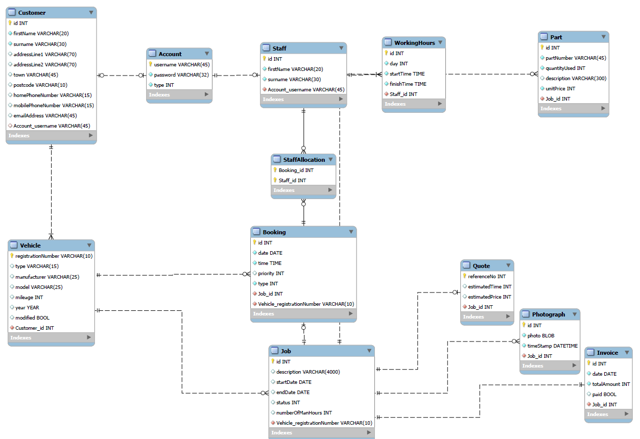

Sql Statements

The Sql statements for the database are contained in entity classes that allow us to use the statements from the classes without needing to repeat code. These classes have Sql statements contained within methods and these methods return a string which can then be used to query that statement. Each class contains their own create table, drop table, alter table, insert, update, delete and foreign key statements that allows changes to be made easily to the database.

Create Table Statements

public string CreateCustomer()
{
string createCustomerTable = "CREATE TABLE Customer ( "
+ "customerId INT PRIMARY KEY IDENTITY ,"
+ "accountUsername VARCHAR(45) NULL ,"
+ "firstName VARCHAR(20) NOT NULL ,"
+ "surname VARCHAR(30) NOT NULL ,"
+ "homePhoneNumber VARCHAR(15) NULL ,"
+ "mobilePhoneNumber VARCHAR(15 NULL ,"
+ "emailAddress VARCHAR(45) NULL )";

return createCustomerTable;
}

Drop Table statement

public string DropJob() {
string dropJobTable = "DROP TABLE Job";
return dropJobTable;
}

Update statement for vehicle
The statement will check if a model is null and if so it will then set the model id and uupdate the remaining fields. However if this is not set to null then the values are inserted directly into the database as the correct data type.

public string update()
{

string updateString;

if (!model.Equals(""))
{
updateString = "DECLARE @MOD_ID int; ";
updateString += "SET @MOD_ID = (SELECT modelId FROM Model WHERE description = '" + this.model + "'); ";
updateString += "Update Vehicle SET modelId=@MOD_ID, mileage='" + this.mileage
+ "', year='" + this.year.ToShortDateString()
+ "', modified='" + Convert.ToInt32(this.modified)
+ "' WHERE (registrationNumber='" + this.registrationNumber + "');";
}
else
{
updateString = "Update Vehicle SET modelId='" + this.modelId
+ "', mileage='" + this.mileage
+ "', year='" + this.year.ToShortDateString()
+ "', modified='" + Convert.ToInt32(this.modified)
+ "' WHERE (registrationNumber='"
+ this.registrationNumber + "');";
}

return updateString;
}

Insert Statements

public string InsertBooking()
{
string insertBooking = "INSERT INTO Booking ("
+ "vehicleRegistrationNumber,date,time,priority,confirmed)"
+ "VALUES ('"
+ this.vehicleRegistrationNumber + "','"
+ this.date.ToLongDateString() + "','"
+ this.time.ToLongTimeString() + "','"
+ this.priority + "','"
+ Convert.ToInt32(this.confirmed) + "')";
return insertBooking;
}

Select Statements

public static Job selectByJobId(int jobId, MySql connection)
{
string selectJob = "SELECT * FROM Job WHERE (jobId='" + jobId + "')";
SqlDataReader jobFromDb = connection.Select(selectJob);

if (jobFromDb != null)
{
if (jobFromDb.HasRows)
{
jobFromDb.Read();
Job returnJob = new Job(Convert.ToInt32(jobFromDb["jobId"]),
Convert.ToInt32(jobFromDb["bookingId"]),
jobFromDb["description"].ToString(),
Convert.ToDateTime(jobFromDb["startDate"]),
Convert.ToDateTime(jobFromDb["endDate"]),
Convert.ToInt32(jobFromDb["status"]),
Convert.ToInt32(jobFromDb["numberOfManHours"]));
jobFromDb.Close();
return returnJob;
}
jobFromDb.Close();
return null;
}
return null;
}

Insert Foreign Key

public string InsertFKJob()
{
string InsertFKJob = "ALTER TABLE Job ADD CONSTRAINT fk_bookingId FOREIGN KEY(bookingId) REFERENCES Booking(bookingId)";

return InsertFKJob;
}

Drop Foreign Key

public string DropFKJob()
{
string DropFKJob = "ALTER TABLE Job DROP CONSTRAINT fk_bookingId";

return DropFKJob;
}

